|  |  |  |
| --- | --- | --- |
| C:\Users\a03551\Desktop\01.png | **Technical Description Wind Farm Remote Monitoring System Solution** | **Date** |
| **1, 2021** |
| **Technical Description Wind Farm**  **Remote Monitoring System Solution**   |  |  |  |  |  | | --- | --- | --- | --- | --- | | **Preparer** | **Checked** | **Standardized** | **Approval** | **Released** | |  |  |  |  |  |  |  |  |  |  | | --- | --- | --- | --- | | **Document No.** |  | **Revision** |  | | **Classification** | | **Number of pages** |  | | **□ Strictly Confidential ■ Confidential □ Secret □ Internal□ Published** | | | | | | |

|  |
| --- |
| **Notification and Disclaimer**  This document may still be undergoing checking by the institution responsible, Although all work has been carried out very thoroughly; this document is still subject to changes. Without permission from MINGYANG, the risk of manufacturing that in accordance to this document or other uses is not in the responsibility of MINGYANG.  Should any information in this document be not complete, incomprehensible or faulty, it is the responsibility of the user of this document to immediately clarify the facts with the author and the client.  This document is only submitted under the assumption that the receiver accepts the above conditions. In case of any divergence of interpretations, the Chinese version shall prevail. |

**List of Valid Documents**

|  |  |  |  |
| --- | --- | --- | --- |
| **Item** | **Document Name** | **Document No.** | **Rev.** |
|  |  |  |  |
|  |  |  |  |
|  |  |  |  |
|  |  |  |  |
|  |  |  |  |

**List of Alterations**

|  |  |  |  |  |
| --- | --- | --- | --- | --- |
| **Item** | **Rev.** | **Modified Pages** | **Modifications** | **Date** |
|  |  |  |  |  |
|  |  |  |  |  |
|  |  |  |  |  |
|  |  |  |  |  |
|  |  |  |  |  |
|  |  |  |  |  |
|  |  |  |  |  |
|  |  |  |  |  |
|  |  |  |  |  |
|  |  |  |  |  |
|  |  |  |  |  |
|  |  |  |  |  |
|  |  |  |  |  |
|  |  |  |  |  |
|  |  |  |  |  |
|  |  |  |  |  |
|  |  |  |  |  |

**Contents**

1. System Overview 5

2. Overall System architecture 5

3. Advantages of Remote Monitoring System 5

4. Remote Monitoring System Function 6

5. Remote Monitoring System Network Structure 7

6. Remote Monitoring System Hardware Configuration 8

7. Applications Supported by the Remote Monitoring System 8

8. Features of Remote Monitoring System 9

# 1. System Overview

The wind farm remote SCADA system refers to the real-time collection and display of the wind turbine operation status and production operation data of the wind farm in the centralized control center of the remote central city or the owner’s headquarters, so that the remote centralized control center can timely and accurately understand the wind farm Production operation status, and can realize control operations such as starting and stopping the WTG.

# 2. Overall System Architecture

The local SCADA system of the wind farm collects wind turbine operation data, transmits it to the remote centralized control center server through the Internet or the power private network, and displays it on the big screen. In order to ensure the security of the data network of the wind farm remote SCADA system, resist various forms of malicious damage and attacks such as hackers, viruses, malicious codes, and prevent the collapse or paralysis of the power secondary system, the transmission network of the wind farm remote SCADA system must be carried out. Security protection to ensure the security of the remote SCADA system and communication data network.

# 3. Advantages of Remote SCADA System

The construction of a remote SCADA system for wind farms can realize centralized monitoring and management of wind farm fans and other equipment, which is very important for improving the company's comprehensive management level, optimizing personnel structure, and improving wind farm power generation efficiency.

(1) Improve the automation level of wind farms

Unattended and few people on duty is the development direction of the wind farm operation model. It puts forward higher requirements on the equipment status, automation level, personnel quality and management level of the wind farm. It is the first-class equipment, first-class talents and first-class wind farms. An important sign of the management of wind farms, the establishment of an automation system that can realize wind farms and remote SCADA is a necessary condition to realize unattended wind farms with few people on duty, and it will greatly promote the overall improvement of wind farm automation.

(2) Improve the economic benefits of wind farms

Set up a wind farm remote SCADA system, which can be connected to multiple wind farms for unified management, establish contact with the local meteorological department, and formulate the production plan of the wind farm in the future period based on the forecast information of the weather department for the future period. Arrange personnel deployment and equipment maintenance plans to make full use of resources and improve the economic benefits of wind farms.

(3) Improve the competitive advantage of wind farms in the power grid

With the increasing scale of wind farms, the proportion of wind power generation in the power grid will become larger and larger. Through the establishment of wind farms and remote SCADA automation systems, the power generation status of each wind farm can be predicted and reported to the grid company. In order to facilitate the formulation of power dispatching plans for power grid companies, and to improve the competitive advantages of power generation companies in the power grid.

(4) Improve company management

Since the wind farm group has the characteristics of many wind farm equipment, scattered distribution, and remote location, if each wind farm is managed separately, it will consume a lot of manpower and material resources. Set up wind farms and remote SCADA systems to realize the centralized operation management, centralized maintenance management, centralized operation management and centralized logistics management of the wind farms. Through the reasonable deployment and use of human resources, tools and spare parts, capital and technology, it can achieve human and financial , Efficient operation of materials and optimal utilization of resources, to ensure the maximum benefit of comprehensive utilization of wind farms.

(5) Improve the ability of wind power to resist risks

According to the characteristics of wind power, the power generation status of wind power is greatly restricted by the local climatic conditions. Bad weather conditions will affect the safe operation of wind farms and cause certain damage to wind farm equipment. Establish wind farms and remote SCADA automation systems, formulate disaster prevention plans under various climatic conditions, and according to the collected weather forecast information of the regions where each wind farm belongs, start the disaster prevention plans as soon as possible for the possible severe weather to ensure The safe operation of wind farms and reduction of disaster losses are necessary.

Through wind farms and remote SCADA automation systems, the wind farms or other new energy projects that belong to all over the country are integrated into a network, and a reliable, safe and stable integrated automation system with complete functions, advanced technology and good performance is established to realize the The wind farm or other new energy sources to be developed shall be monitored, controlled and managed in a unified manner.

# 4. Remote SCADA System Function

The remote SCADA system can realize the data collection, monitoring and control of the fan operation, and can realize the functions of four remotes (remote signaling, remote measurement, remote adjustment and remote control) for the fan through this system.

(1) Data collection function

Receive information such as the operating status, operating data, and alarm codes of the wind turbine sent from the on-site wind turbine monitoring background of the wind farm;

(2) Data processing function

Carry out availability checks on the various data received;

Generate historical data records;

Generate various operating reports;

Generate various curve charts;

It has the ability of data statistics, summarizing wind turbine running time, active power, reactive power, available power, power accumulation, statistics and analysis, equipment failure alarm statistics and analysis, etc.

(3) Screen display

The remote SCADA system host displays various information screens of the wind farm. The display content mainly includes the operating status of all wind turbines, power generation, equipment temperature and other parameters, real-time data of each measured value, various alarm information, and network system status information.

(4) Alarm and record

When the operating status of the equipment changes or the parameters exceed the set value, etc., the abnormal situation will be recorded, and the sound and light and voice alarm will be issued to report to the staff on duty in time.

(5) Control function

When the wind farm is in the "remote SCADA" control mode, the operator of the centralized control center can remotely control the wind turbine through the remote SCADA system. The control operations include: wind turbine start, stop, reset, etc.

When a wind farm is in the "wind farm monitoring" mode, the wind turbine is only controlled by the local monitoring system and does not accept control commands from the remote SCADA system. The operator of the centralized control center can only monitor the running status of the fan, and cannot perform control operations;

The switching of the control mode is authorized by the wind farm operator or the operator of the remote SCADA system of the centralized control center. The switching authority can be set and assigned to different users.

(6) Operation authority management

It has the function of operation authority level management. Only when the correct operation account number and user password are entered can the operation control, parameter modification, and information be recorded. And has the function of recording the operation modification person and operation content. The system sets passwords for different operation levels, and different personnel have different operation levels and permissions.

# 5. Remote SCADA System Network Structure

(1) System network structure

The remote SCADA system adopts Ethernet transmission technology, adopts TCP/IP protocol, and transmits through INTERNET or electric power network. The fan monitoring system in the station communicates with the remote SCADA system through the core switch, and reserves communication interfaces with other systems.

According to the remote data monitoring requirements of the electric power industry, to ensure data security, it is generally required to use the electric power network as the transmission medium. If you connect to the Internet through optical fiber, ISDN, ADSL, etc., and realize remote SCADA by applying for a fixed network IP address or VPN from the operator, you must be equipped with a complete network router and firewall.

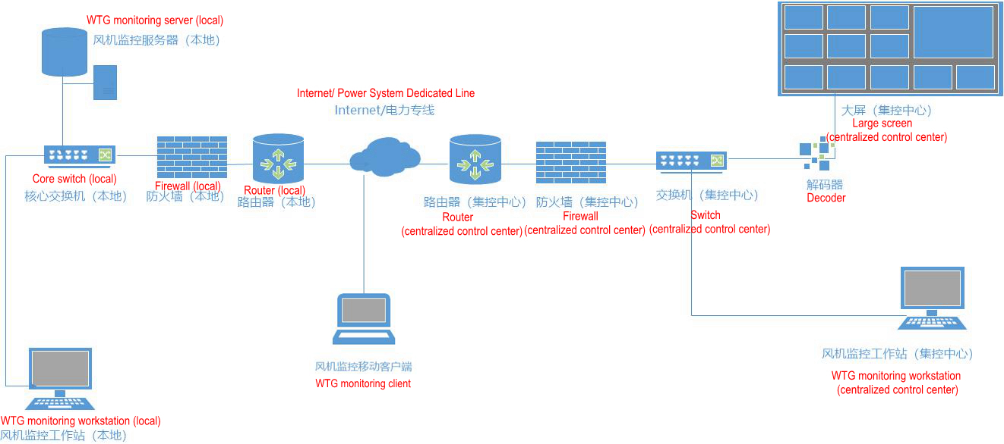

Fig5.1 Topological diagram of system structure

# 6. Remote SCADA System Hardware Configuration

According to the remote SCADA system function and application design requirements, the main hardware configuration of the system is as follows:

|  |  |  |  |
| --- | --- | --- | --- |
| **Name** | **Qty.** | **Unit** | **Description** |
| Real-time data server | 1 | Set | Real-time data acquisition, data processing, real-time database update and management, system clock management, etc. |
| Operator workstation | 2 | Set | Used to run various man-machine interface software. The operation personnel on duty implement various tasks such as monitoring, control and management of the monitored objects of the wind farm through the operator station. |
| Voice alarm host | 1 | Piece | Used for voice alarm prompts when the monitored object has an accident or failure |
| router | 2 | Set | Used for communication channels with various wind farms and superior management departments |
| Hardware firewall | 2 | Set | Control the information flow into and out of the network according to the network structure and security policy, with strong anti-attack ability |
| Backbone switch | 2 | Set | Form the backbone network of the remote SCADA system |
| Large screen display | 1 | Set | Display monitoring and image monitoring screen |
| UPS power supply | 1 | Set | Power supply guarantee for system and network equipment |

# 7. Applications Supported by the Remote SCADA System

(1) Software configuration

The wind farm remote SCADA system is equipped with rich, complete system software, support software and application software that meets functional requirements.

(2) System software

operating system

Language compiler

File management

System self-diagnosis, self-recovery software

Network software

Other system software

(3) Support software

The system has various tools and software for system generation, software secondary development, system operation and maintenance

Database management software

Interactive database editing tool

Interactive screen editing tool

Interactive report editing tool

Other tools

(4) Application software

The system provides a complete set of application software to complete the functions. The application software adopts modular design, and each application program runs as an independent unit, which is easy to maintain. There are:

Data acquisition and data processing

Control and safety monitoring

Man-machine interface

Alarm, record display, query and print

Wind farm communications

System clock management

# 8. Features of Remote SCADA System

(1) It has strict security transmission methods to ensure the remote transmission of production data, and has a multi-level authority control system, hierarchical management, to ensure the security of management data.

(2) The system supports expansion and upgrade, access to data from booster stations, wind towers, and weather to form a comprehensive comparative analysis.

(3) General report statistics for wind farms, and output comparative analysis can be realized through intuitive graphical display.

(4) Production daily, monthly, annual report and any time period report statistics.